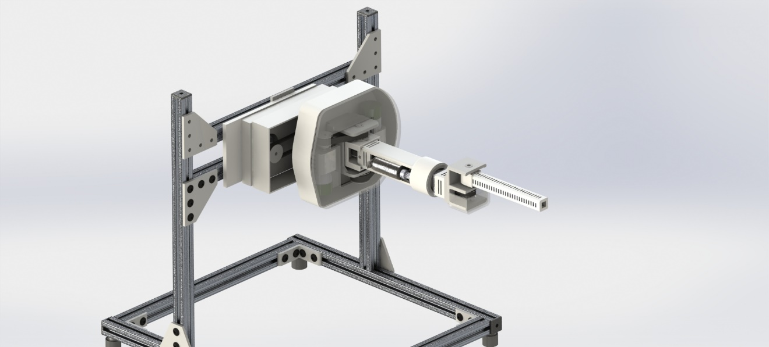

Mass properties of selected components

Coordinate system: Link_1

The center of mass and the moments of inertia are output in the coordinate system of assembly

Mass = 0.66393 kilograms

Volume = 0.00065 cubic meters

Surface area = 0.28836 square meters

Center of mass: ( meters )

X = 0.00075

Y = 0.02922

Z = 0.00382

Principal axes of inertia and principal moments of inertia: ( kilograms * square meters )

Taken at the center of mass.

Ix = ( 0.98715, -0.00206, 0.15981) Px = 0.00130

Iy = ( 0.15981, -0.00160, -0.98715) Py = 0.00201

Iz = ( 0.00229, 1.00000, -0.00125) Pz = 0.00294

Moments of inertia: ( kilograms * square meters )

Taken at the center of mass and aligned with the output coordinate system.

Lxx = 0.00132 Lxy = 0.00000 Lxz = 0.00011

Lyx = 0.00000 Lyy = 0.00294 Lyz = 0.00000

Lzx = 0.00011 Lzy = 0.00000 Lzz = 0.00200

Moments of inertia: ( kilograms * square meters )

Taken at the output coordinate system.

Ixx = 0.00189 Ixy = 0.00001 Ixz = 0.00011

Iyx = 0.00001 Iyy = 0.00295 Iyz = 0.00007

Izx = 0.00011 Izy = 0.00007 Izz = 0.00256

Mass properties of selected components

Coordinate system: Link_2

The center of mass and the moments of inertia are output in the coordinate system of assembly

Mass = 0.34366 kilograms

Volume = 0.00016 cubic meters

Surface area = 0.09156 square meters

Center of mass: ( meters )

X = 0.01109

Y = -0.00003

Z = -0.08500

Principal axes of inertia and principal moments of inertia: ( kilograms * square meters )

Taken at the center of mass.

Ix = ( 0.06986, -0.00164, -0.99756) Px = 0.00010

Iy = (-0.99755, -0.00449, -0.06985) Py = 0.00055

Iz = (-0.00436, 0.99999, -0.00195) Pz = 0.00058

Moments of inertia: ( kilograms * square meters )

Taken at the center of mass and aligned with the output coordinate system.

Lxx = 0.00055 Lxy = 0.00000 Lxz = -0.00003

Lyx = 0.00000 Lyy = 0.00058 Lyz = 0.00000

Lzx = -0.00003 Lzy = 0.00000 Lzz = 0.00010

Moments of inertia: ( kilograms * square meters )

Taken at the output coordinate system.

Ixx = 0.00303 Ixy = 0.00000 Ixz = -0.00036

Iyx = 0.00000 Iyy = 0.00311 Iyz = 0.00000

Izx = -0.00036 Izy = 0.00000 Izz = 0.00014

Mass properties of selected components

Coordinate system: Link_3

The center of mass and the moments of inertia are output in the coordinate system of assembly

Mass = 0.10602 kilograms

Volume = 0.00009 cubic meters

Surface area = 0.04644 square meters

Center of mass: ( meters )

X = 0.00000

Y = 0.03581

Z = 0.02211

Principal axes of inertia and principal moments of inertia: ( kilograms * square meters )

Taken at the center of mass.

Ix = ( 0.00000, 0.98319, 0.18260) Px = 0.00005

Iy = (-0.00001, -0.18260, 0.98319) Py = 0.00013

Iz = ( 1.00000, 0.00000, 0.00000) Pz = 0.00014

Moments of inertia: ( kilograms * square meters )

Taken at the center of mass and aligned with the output coordinate system.

Lxx = 0.00014 Lxy = 0.00000 Lxz = 0.00000

Lyx = 0.00000 Lyy = 0.00006 Lyz = 0.00001

Lzx = 0.00000 Lzy = 0.00001 Lzz = 0.00012

Moments of inertia: ( kilograms * square meters )

Taken at the output coordinate system.

Ixx = 0.00033 Ixy = 0.00000 Ixz = 0.00000

Iyx = 0.00000 Iyy = 0.00011 Iyz = 0.00010

Izx = 0.00000 Izy = 0.00010 Izz = 0.00026

Mass properties of selected components

Coordinate system: Link_4

The center of mass and the moments of inertia are output in the coordinate system of assembly

Mass = 0.04566 kilograms

Volume = 0.00004 cubic meters

Surface area = 0.03246 square meters

Center of mass: ( meters )

X = 0.00000

Y = 0.00000

Z = -0.09265

Principal axes of inertia and principal moments of inertia: ( kilograms * square meters )

Taken at the center of mass.

Ix = ( 0.00000, 0.00000, -1.00000) Px = 0.00000

Iy = ( 0.00000, 1.00000, 0.00000) Py = 0.00013

Iz = ( 1.00000, 0.00000, 0.00000) Pz = 0.00013

Moments of inertia: ( kilograms * square meters )

Taken at the center of mass and aligned with the output coordinate system.

Lxx = 0.00013 Lxy = 0.00000 Lxz = 0.00000

Lyx = 0.00000 Lyy = 0.00013 Lyz = 0.00000

Lzx = 0.00000 Lzy = 0.00000 Lzz = 0.00000

Moments of inertia: ( kilograms * square meters )

Taken at the output coordinate system.

Ixx = 0.00052 Ixy = 0.00000 Ixz = 0.00000

Iyx = 0.00000 Iyy = 0.00052 Iyz = 0.00000

Izx = 0.00000 Izy = 0.00000 Izz = 0.00000